1. **Setup a remote repository in Local , Add a file and commit or save the changes and push to master branch**

**PS D:\SM Practice\celebal> echo "# Celebal_Assignment" >> README.md**

**>> git init**

**>> git add README.md**

**>> git commit -m "first commit"**

**>> git branch -M main**

**>> git remote add origin https://github.com/vaidik2626/Celebal_Assignment.git**

**>> git push -u origin main**

Initialized empty Git repository in D:/SM Practice/celebal/.git/

[master (root-commit) eb677cd] first commit

1 file changed, 0 insertions(+), 0 deletions(-)

create mode 100644 README.md

Enumerating objects: 3, done.

Counting objects: 100% (3/3), done.

Writing objects: 100% (3/3), 254 bytes | 254.00 KiB/s, done.

Total 3 (delta 0), reused 0 (delta 0), pack-reused 0

To https://github.com/vaidik2626/Celebal_Assignment.git

* [new branch] main -> main

branch 'main' set up to track 'origin/main'.

**PS D:\SM Practice\celebal> echo "Hello, World!" > file.txt**

**>> git add file.txt**

**>> git commit -m "Add initial file.txt"**

**>>**

[main b51367c] Add initial file.txt

1 file changed, 0 insertions(+), 0 deletions(-)

create mode 100644 file.txt

**PS D:\SM Practice\celebal> git push origin master**

**>>**

error: src refspec master does not match any

error: failed to push some refs to 'https://github.com/vaidik2626/Celebal_Assignment.git'

**PS D:\SM Practice\celebal> git branch -M main**

**>> git push -u origin main**

**>>**

Enumerating objects: 4, done.

Counting objects: 100% (4/4), done.

Delta compression using up to 8 threads

Compressing objects: 100% (2/2), done.

Writing objects: 100% (3/3), 313 bytes | 313.00 KiB/s, done.

Total 3 (delta 0), reused 0 (delta 0), pack-reused 0

To https://github.com/vaidik2626/Celebal_Assignment.git

eb677cd..b51367c main -> main

branch 'main' set up to track 'origin/main'.

1. **Create a new branch then commit and push the changes to new branch and merge it with the master branch using pull request.**

**PS D:\SM Practice\celebal> git checkout -b new_feature**

Switched to a new branch 'new_feature'

**PS D:\SM Practice\celebal> echo "New feature" > feature.txt**

**>> git add feature.txt**

**>> git commit -m "Add new feature"**

**>> git push -u origin new_feature**

[new_feature 255b947] Add new feature

1 file changed, 0 insertions(+), 0 deletions(-)

create mode 100644 feature.txt

Enumerating objects: 4, done.

Counting objects: 100% (4/4), done.

Delta compression using up to 8 threads

Compressing objects: 100% (2/2), done.

Writing objects: 100% (3/3), 333 bytes | 166.00 KiB/s, done.

Total 3 (delta 0), reused 0 (delta 0), pack-reused 0

remote:

remote: Create a pull request for 'new_feature' on GitHub by visiting:

remote: https://github.com/vaidik2626/Celebal_Assignment/pull/new/new_feature

remote:

To https://github.com/vaidik2626/Celebal_Assignment.git

* [new branch] new_feature -> new_feature

branch 'new_feature' set up to track 'origin/new_feature'.

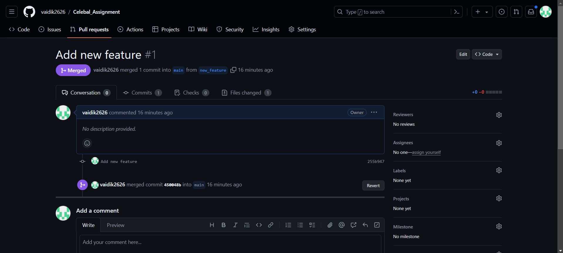

**PS D:\SM Practice\celebal> git checkout main**

Switched to branch 'main'

Your branch is up to date with 'origin/main'.

1. **Undo the last commit or remove the last created file from remote repo using CLI**

**PS D:\SM Practice\celebal> git reset --soft HEAD~1**

**>> git push origin main --force**

Total 0 (delta 0), reused 0 (delta 0), pack-reused 0

To https://github.com/vaidik2626/Celebal_Assignment.git

+ 450048b...eb677cd main -> main (forced update)

**PS D:\SM Practice\celebal> git rm feature.txt**

fatal: pathspec 'feature.txt' did not match any files

**PS D:\SM Practice\celebal> git checkout new_feature**

Switched to branch 'new_feature'

Your branch is up to date with 'origin/new_feature'.

**PS D:\SM Practice\celebal> git rm feature.txt**

rm 'feature.txt'

**PS D:\SM Practice\celebal> git commit -m "Remove feature.txt"**

**>> git push origin main**

[new_feature 716fc90] Remove feature.txt

1 file changed, 0 insertions(+), 0 deletions(-)

delete mode 100644 feature.txt

Everything up-to-date

1. **Resolve a merge conflicts**

**PS D:\SM Practice\celebal> git checkout main**

**>> echo "Conflicting change" > conflict.txt**

**>> git add conflict.txt**

**>> git commit -m "Add conflicting change"**

**>> git push origin main**

**>>**

**>> git checkout new_feature**

**>> echo "Another change" > conflict.txt**

**>> git add conflict.txt**

**>> git commit -m "Add another change"**

**>> git push origin new_feature**

**>>**

Switched to branch 'main'

Your branch is up to date with 'origin/main'.

[main 4809540] Add conflicting change

1 file changed, 0 insertions(+), 0 deletions(-)

create mode 100644 conflict.txt

Enumerating objects: 4, done.

Counting objects: 100% (4/4), done.

Delta compression using up to 8 threads

Compressing objects: 100% (2/2), done.

Writing objects: 100% (3/3), 323 bytes | 323.00 KiB/s, done.

Total 3 (delta 0), reused 0 (delta 0), pack-reused 0

To https://github.com/vaidik2626/Celebal_Assignment.git

eb677cd..4809540 main -> main

Switched to branch 'new_feature'

Your branch is ahead of 'origin/new_feature' by 1 commit.

(use "git push" to publish your local commits)

[new_feature a753a4a] Add another change

1 file changed, 0 insertions(+), 0 deletions(-)

create mode 100644 conflict.txt

Enumerating objects: 6, done.

Counting objects: 100% (6/6), done.

Delta compression using up to 8 threads

Compressing objects: 100% (4/4), done.

Writing objects: 100% (5/5), 586 bytes | 586.00 KiB/s, done.

Total 5 (delta 0), reused 0 (delta 0), pack-reused 0

To https://github.com/vaidik2626/Celebal_Assignment.git

255b947..a753a4a new_feature -> new_feature

**PS D:\SM Practice\celebal> git checkout main**

Switched to branch 'main'

Your branch is up to date with 'origin/main'.

**PS D:\SM Practice\celebal> git pull origin main**

From https://github.com/vaidik2626/Celebal_Assignment

* branch main -> FETCH_HEAD

Already up to date.

**PS D:\SM Practice\celebal> git checkout new_feature**

>> git pull origin new_feature

Switched to branch 'new_feature'

Your branch is up to date with 'origin/new_feature'.

From https://github.com/vaidik2626/Celebal_Assignment

* branch new_feature -> FETCH_HEAD

Already up to date.

**PS D:\SM Practice\celebal> git checkout main**

>> git merge new_feature

Switched to branch 'main'

Your branch is up to date with 'origin/main'.

warning: Cannot merge binary files: conflict.txt (HEAD vs. new_feature)

Auto-merging conflict.txt

CONFLICT (add/add): Merge conflict in conflict.txt

Automatic merge failed; fix conflicts and then commit the result.

**PS D:\SM Practice\celebal> git add conflict.txt**

**>> git commit -m "Resolve merge conflict"**

**>> git push origin main**

[main b326f61] Resolve merge conflict

Enumerating objects: 4, done.

Counting objects: 100% (4/4), done.

Delta compression using up to 8 threads

Compressing objects: 100% (2/2), done.

Writing objects: 100% (2/2), 339 bytes | 339.00 KiB/s, done.

Total 2 (delta 0), reused 0 (delta 0), pack-reused 0

To https://github.com/vaidik2626/Celebal_Assignment.git

4809540..b326f61 main -> main

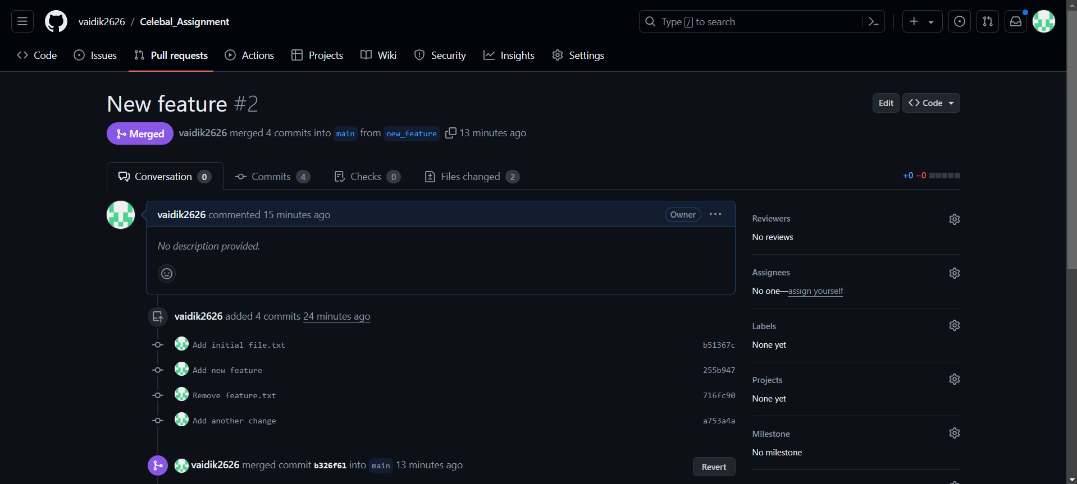

1. **Practice More git commands**

**PS D:\SM Practice\celebal> git log**

commit b326f61d1fefaa0c07074715cd935a17a57ea5d9 (HEAD -> main, origin/main)

Merge: 4809540 a753a4a

Author: vaidik2626 <21it047@charusat.edu.in>

Date: Sun Jun 9 14:57:25 2024 +0530

Resolve merge conflict

commit a753a4acfc260fc4388858a9b76ff11854356d84 (origin/new_feature, new_feature)

Author: vaidik2626 <21it047@charusat.edu.in>

Date: Sun Jun 9 14:55:02 2024 +0530

Add another change

commit 480954011857e3870467d7d7ee5388582c5d1e6c

Author: vaidik2626 <21it047@charusat.edu.in>

Date: Sun Jun 9 14:54:59 2024 +0530

Add conflicting change

commit 716fc906b841da3af62d2f1bc2ed74cdaa4fc456

Author: vaidik2626 <21it047@charusat.edu.in>

Date: Sun Jun 9 14:54:26 2024 +0530

Remove feature.txt

commit 255b9470d22f1db4af5c97108d2392853b001e15

Author: vaidik2626 <21it047@charusat.edu.in>

Date: Sun Jun 9 14:49:41 2024 +0530

Add new feature

commit b51367cae120984e62a1350fead5d82a51e9cc5c

Author: vaidik2626 <21it047@charusat.edu.in>

Date: Sun Jun 9 14:47:02 2024 +0530

Add initial file.txt

commit eb677cdcd938a91f5be6213c6a19c58e34cb8d2e

Author: vaidik2626 <21it047@charusat.edu.in>

Date: Sun Jun 9 14:46:45 2024 +0530

first commit

**PS D:\SM Practice\celebal> git branch**

* main

new_feature

**PS D:\SM Practice\celebal> git branch -d new_feature**

>> git push origin --delete new_feature

>>

Deleted branch new_feature (was a753a4a).

To https://github.com/vaidik2626/Celebal_Assignment.git

- [deleted] new_feature

PS D:\SM Practice\celebal> git stash

No local changes to save

**PS D:\SM Practice\celebal> git stash**

**>> git stash pop**

**>>**

No local changes to save

No stash entries found.

**PS D:\SM Practice\celebal> git diff**

**PS D:\SM Practice\celebal>**